Year 8 participated in Equality Workshops June 2023

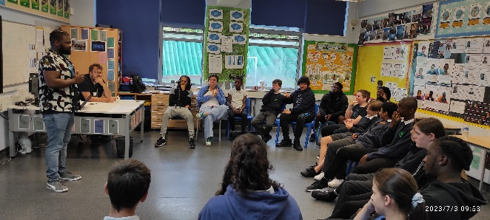
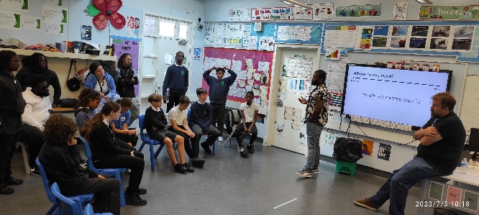
Year 8 participated in Equality Workshops run by the Lewisham Young Mayor Project. Pupils explored stereotypes & the reasonings behind them. They reflected on how to challenge discrimination in everyday life. Pupils’ feedback were, “I didn’t know” “It was very insightful” “I felt understood”.
Some thought provoking questions…



