

A PARENT'S GUIDE TO BLACK LIVES MATTER

Resources, Activities, and Tips for Families to empower children to work towards racial equality

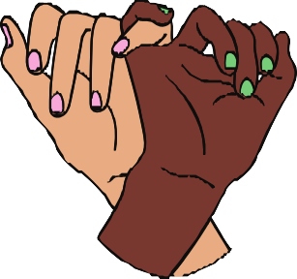
CONTENTS

A quick introduction (pg.3)

What is the Black Lives Matter movement? (pg. 3-4) How do I explain George Floyd to my children? (pg.5-6)
How do I open a conversation with children on race and racism? (pg. 6-8) How do I explain White Privilege? (pg.9)
It's not just a narrative of struggle (pg.10)

The danger of saying "My child isn't racist" (pg.11) Being a role model through action (pg.12)
Educational resources for you and your family (pg.13-19)
- Books (for younger children, older children and parents)
- Online resources (for parents)
- Podcasts (for older children and parents)
- Films & documentaries (for younger children, older children and parents)

Credits (page 20.)

A parent's guide to Black Lives Matter A quick introduction

A quick introduction

Peaceful protests, mass marches, and portrayals of violence. Petitions, political speeches, and demonstrations. The last two weeks have seen movements advocating for an end to racial inequality on a mass scale. Yet, current affairs aren’t always tangible or immediately clear, especially from a child’s perspective.
Black Lives
Matter

Many children may have questions about the images, stories, and conversations they hear on the news and around them. We can’t solely rely on schools to ensure children fully understand the Black Lives Matter movement and the issues that fuel the movement.
As parents, if we haven’t already, it is also our responsibility to engage in positive and open discussions about race and racism with our children at home.

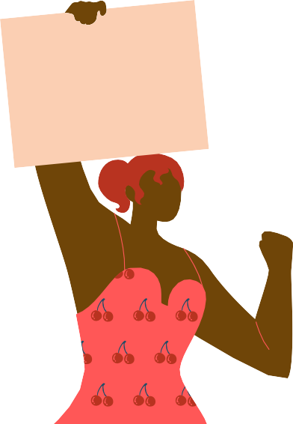
Perhaps race has always been a topic of regular discussion in your family, or perhaps you feel unsure about how to approach the topic of race with your family. Perhaps you grew up never talking about race, or perhaps you regularly face discrimination.
Justice For
George
Floyd
This guide aims to provide resources, advice, and tips to ensure that children are aware of racial inequality, racial hierarchies, and white privilege present in modern-day society, as well as share tools and knowledge in which to combat racism today.
Racism and race is not a one-conversation topic, and our guide by no means contains all the answers, we simply hope to provide the foundations of good places to start help inspire discussion and empower families to work towards racial equality.

What is the Black Lives Matter (BLM) movement?
In 2012, 17-year old African-American Trayvon Martin was killed by a member of neighbourhood watch, George Zimmerman. The police told Zimmerman not to pursue Trayvon for looking suspicious, but he didn’t listen and fatally shot him. There was a lot of racial bias during the trial and Zimmerman was acquitted for the crime.
In response, Black Lives Matter movement was formed.

3.)

A parent's guide to Black Lives Matter What is the BLM movement?

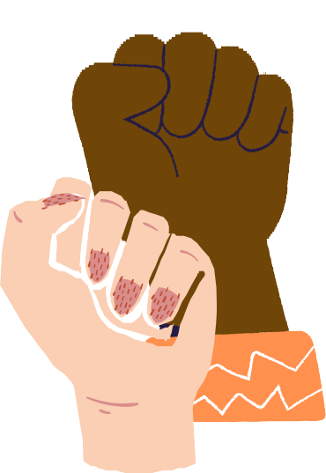
The movement seeks to “eradicate white supremacy, stop violence inflicted on Black communities, and create a safe space for Black communities, imagination, and innovation.” It speaks out against police brutality and unaccountability, not solely with regard to George Floyd, but also Breonna Taylor, Ahmaud Arbery, and the thousands of victims wrongly treated by the police. Whilst it is not a new movement, its message is central to the present anti-racist movement. The statement "Black Lives Matter" refers to a Twitter hashtag, an anthem, a slogan, a social movement, or movements and groupings for racial justice. It has grown to become a global movement - an international human rights movement - to combat racism in modern-day society.

But how do we explain this to our children?

When we explain BLM to children, you’re not saying that nobody else matters. However, by encouraging ‘all lives matter’ as parents we risk taking away the real difficulty felt by Black communities. There are child-friendly analogies to help children understand Black Lives Matter:

1.) Imagine if you broke your leg and had to go to the Doctor. You would want to tell the Doctor
4.)
for Black lives are in
danger!
We just need your help
with #BlackLivesMatter
We know: that all
lives matter
We never said: Only
Black lives matter
We said: Black Lives
Matter
that right now, your leg was in pain. Whilst ALL your bones matter, right now, it’s your leg that needs attention.

2.) Imagine you were running a race to raise money at a cancer fundraiser, and someone said to you
'But don't all diseases matter?' Of course they do, but right now, it's cancer that needs funding

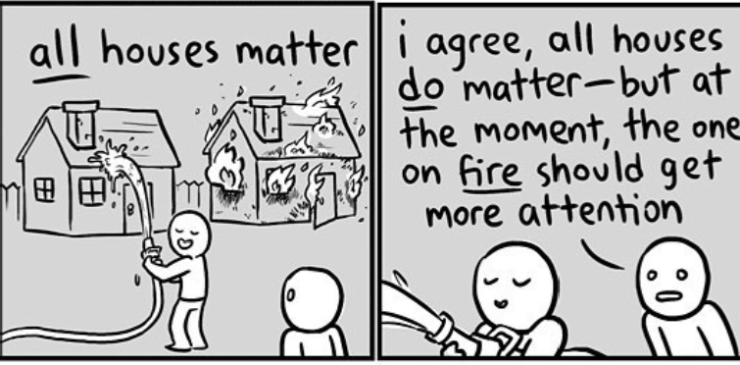
3.)

illustration credit: Kris Straub

A parent's guide to Black Lives Matter How do I explain George Floyd to my children?

How do I explain george floyd To my children?
Perhaps, prior to the death of George Floyd, you viewed racism as something ‘of the past’ or ‘something that doesn’t happen here.’ When talking about the tragedy of George Floyd and similar incidents, it’s important to emphasise that racism hasn’t suddenly appeared from nowhere.

For younger children:

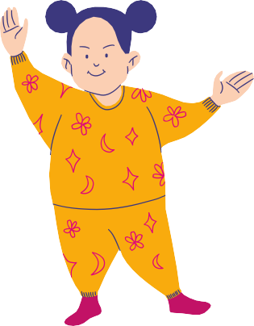
Explaining the current events can be made comprehensible through a child-friendly lens. How would your child feel if their friend said something mean to them or pushed them because of something they couldn’t control? What if they then did it again, even after he/she asked them to stop? And then again, and no one at school helped them? Eventually, they would feel upset and angry. In some ways, this is like the George Floyd tragedy.

Incidents of bad behaviour and mistreatment have happened regularly for decades, and no matter how many times people said ‘stop’ or asked for help, little was done. George Floyd’s death was the straw that broke the camel’s back.

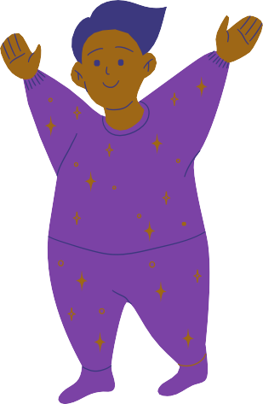
Younger children may find it difficult to understand police brutality, so it’s important to explain that while police officers should be kind and helpful, this is not always the case, linking it to the notion of ‘fairness.’

This can also be a good time to teach children about prejudice and that we should never judge a person’s character by their physical appearance. Often in our society, and consequently the policing system, there are presumptions of what a 'dangerous' person looks like, which has fuelled many of these acts of police brutality. We should remind our children that a person with a darker skin colour should not be associated with negative characteristics such as being dangerous or unkind, and that we should never judge a book by its cover.
5.)

A parent's guide to Black Lives Matter
How do I explain George Floyd to my children?
For older children (secondary school):

With a greater understanding of the world and events around them, as parents, we can expand on the above to teach our children history of race and racial injustice present in modern-day society. We should make sure our children understand that the effects of the slave trade did not just stop at its abolition, but its effects are still seen and felt today.
It’s important to know about current injustices, previous injustices, and cases in which
people have bravely spoken out such as (but not limited to):


For a better understanding of these topics yourself before approaching them with your children, we’ve linked a range of helpful resources at the end of this guide.
1.)
Apartheid in the Republic of South Africa (RSA)
2.) Key figures such as Martin Luther King, Malcolm X,
Nelson Mandela, Rosa Parks
3.)
Windrush in the UK
4.) The American Civil War
5.) Examples of everyday discrimination: eg.) CV responses with ‘black’ sounding names being less likely to be contacted, fashion industries prioritising white beauty, disproportionate stop and searches by the police

6.) Grenfell Tower Inquiry
7.) The role of Black soldiers in WWI and WWII & treatment post-war

How do i open a conversation with children on race and racism?
For some families, particularly white or non-black people of colour, discussions on race and racial inequality may feel like fairly new territory. It can be easy to get used to not thinking about racial identity if it doesn’t personally impact us negatively during everyday life.

6.)

A parent's guide to Black Lives Matter How do I open a conversation on race and racism?

Recent events have underscored that parents and caregivers must play an integral role in ensuring children have an acute awareness of white privilege, racial bias, and racial hierarchies present in society and the ways in which we can combat racism.

It’s quite natural to feel uncomfortable as a parent when engaging in such discussions, especially when it’s not a topic that you’re used to talking about. As Ijeoma Oluo, the author of “So You Want to Talk About Race” tells us:

“If you’re white, and you don’t want to feel any of that pain by having these conversations, then you are asking people of colour to continue to bear the entire burden of racism alone.”


Often, we are so afraid of saying the ‘wrong thing’ that we don’t engage at all. As a consequence, our children don’t learn about the racism that exists today, how to be open to criticism or how to reshape their views. We can also make an active effort to encourage discussion on race. If we immediately shut down our children’s remarks or comments on race, we risk making it into a taboo topic.

Invite children to actively see colour, to see culture, to see history, and to acknowledge that race has an impact on people’s life experiences.

So how can we best do this and what can we say?

Younger children:
Explaining recent events and the deep complexities racism pose are understandably difficult to approach with younger children. How do we explain race and the racism that exists today in an age-appropriate manner?
A good first step is to frame race and its present inequalities through the lens of how a child experiences the world, such as ‘fairness.’ From an early age, we hear our children say ‘it’s not fair.’ Highlighting examples of situations that ‘are not fair’ and ‘are fair’ is a tangible lens in which young children are able to better understand racial injustice.
For example:
7.)

"If we went to the shop and I gave your little sister 5 sweets and only gave you 1, how would that make you feel?"
"If you were hungry and I made dinner for everyone but didn't give you any, do you think that is fair?"

"If you did something wrong and I punish you by taking away your favorite toy and your sister did the same thing and I gave her a treat... do you think thats fair?"

A parent's guide to Black Lives Matter How do I open a conversation about race and racism?

Use simple language and make it clear that you feel the treatment of George Floyd by a police officer was not fair, and that in our family we think everyone should be treated fairly. Personalising your explanation will help make it more tangible, and if you can relate the discussion either to yourselves, your children’s friends or your own family members and friends, it can help to bring these topics closer to home to highlight their importance.


Children absorb their surroundings from a young age, therefore as parents, we can also actively expose our children to diverse books, films, cartoons, and music to ensure our children do not associate influential heroes, the most ‘beautiful’ princesses, or the loudest voices as solely white.
Some examples can be found in the resource section of our guide.

Older children (10+):

Most older children have an awareness of what is going on in the world around them. As parents we should, therefore, allow our children to lead the conversation by providing a safe and comfortable environment in which they are able to express themselves.
Ask your children questions:
What do they know about race?

Have they witnessed racism or ever been mean to someone with different skin colour?
What is their interpretation and opinion of recent events?

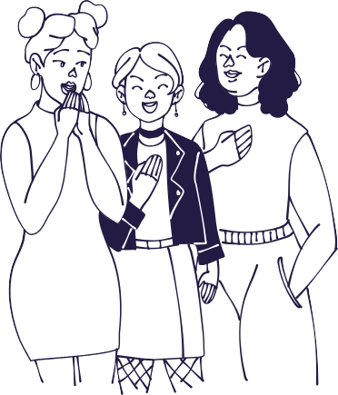
The case of Shukri Abdi highlights that racial bullying is still present, and as parents, we should take the time to understand the behaviour of our own children. There is a good chance that children pick up on other children's ideas/ behaviours that we aren't always aware of, and often those will be the ideas they stick with unless children can openly discuss and process them!
By listening about what our children know, we can then build on their conversation and help fill the more difficult or challenging gaps.

Providing our children with resources from BAME creatives - books, film, podcasts, music etc - is also a great way to start (see the resources section at the end of this guide).

8.)

A parent's guide to Black Lives Matter How do I explain white privilege?

How do i explain white privilege?
There is an excellent video that perfectly captures the concept of privilege. A group of
people line up to start a race. The referee asks questions, such as ‘take two step forwards if you have never helped your parents with bills' and 'if you never wondered where your next meal was coming from' After 5 or so questions, the race begins, with the runners at very different starting lines. Naturally, those who were able to step closer to the finish line were at a huge advantage.
A key message from this video is that these things are not in the individual’s control, and did not come from any of the decisions they made. That is privilege. Here’s the video: https://youtu.be/4K5fbQ1-zps

When we talk about white privilege with our children, you’re not saying life isn’t sometimes tricky or that hardship doesn’t exist in white communities. Rather, when explaining white privilege you’re saying that hardships or difficult moments experienced in life are not a result of your skin colour. This can be explained in child- friendly hypotheses such as ‘imagine if I had a chocolate bar and I gave it to every white person for free but made black people pay.’
Or ‘imagine if we went to swimming lessons and a white child could enter a competition after swimming 2 laps, but a person of colour had to swim 4 laps to enter the same competition.’
By underscoring the unfairness of such stories, a child will better understand the difficulties race wrongly poses today.

It’s important to understand, and to explain to our children, that the concept of white privilege is not an attack on white people, but is a reflection of the reality that many communities across the world are affected by. As an individual, we can’t eradicate it completely from society as it is deeply ingrained into many of our systems and institutions.
However, the biggest first step we can take is to recognise that it exists and then to reflect upon how that impacts ourselves and others in our immediate and wider circles. Understanding the origins and the history of white privilege, which dates back to the colonial era and has continued and evolved throughout more recent history, is equally as important and allows us to identify how we can change our individual actions to uplift those who might not have the same privileges as others.

9.)

A parent's guide to Black Lives Matter It's not just a narrative of struggle

It's not just a narrative of struggle
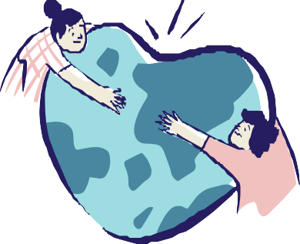
As parents, whilst it is important to underscore the importance of racism both today and throughout history, it is equally important to celebrate Black achievements, contributions, and history outside a frame of just struggle. Currently, British school pupils briefly touch on Black history from the 15th century onwards, and at most, learning is solely centered on the slave trade or civil rights movements during history lessons, creating one narrative of victimhood and inferiority.

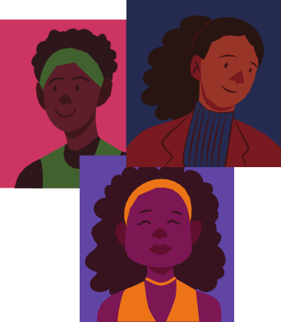
We can expose our children to different cuisines, Black authors, Black musicians, and Black artists and help our children celebrate diversity. At the same time as introducing our children to new perspectives, ideas and culture, this also allows us to support Black-owned businesses in this way, and as such doing our part to help reduce some of the economic inequalities they face. Some directories of Black-owned businesses in the UK can be found at UK Black Owned and Black2Business.

As well as this, we can and should recognise the contributions that Black inventors, scientists and politicians have made towards many of the modern-day amenities that are used everyday, giving them the credit that’s well deserved. While Thomas Edison is renowned for inventing the lightbulb, few people know that it was actually an African- American inventor, Lewis Latimer, who invented the carbon filament that allows the bulb to function. Other inventions which were pioneered or greatly improved by Black inventors include the three-light traffic light system (Garrett Morgan, 1923), refrigerated trucks (Frederick McKinley Jones, 1940) and the first colour PC monitor (Mark Dean, 1980).

These are just a few great trivia facts that can even set your kids apart from others in their class or friendship group, and a way for children to show off their knowledge about the world (as well as boosting their chances in Trivial Pursuit).

Black history goes much more beyond slavery, and it’s important to learn about the rich history of Africa before this era. In contrast to some of portrayals we see of Africa being an impoverished, suffering continent with a dark past, Africa during the Moor Civilisation (until 1500s) was well-respected, with many conquests and contributions towards European culture. You can find out more about Moor history in some of the resources listed below.

The ethnic heritage and contributions of our communities is something valuable that’s worth exploring and helps us to acknowledge that they are multidimensional, beautiful

and inspirational with many positive elements.

10.)

A parent's guide to Black Lives Matter The danger of saying 'my child isn't racist'

the danger of saying 'my child isn't racist'
Many parents may shy away from discussions of race, under the preconception that ‘my kids wouldn’t behave like this.’ However, there is still plenty your children can do to ensure that school, playgrounds, and activities are not tainted with racial injustice. Even if you think your kids wouldn’t personally engage in racist behaviour, there are still things they can do to help.



Encouraging our children to speak up and stand up to racism is not asking your child to fully understand exactly what it feels like to be oppressed. Rather as parents we should be helping them to learn to take on and understand the struggle as if it were their own.
The Guide to Allyship suggests to:
1.)
Stand up, even when you feel scared
2.) Transfer the benefits of your privilege to those
who lack it
3.) Acknowledge that while you too feel pain, the
conversation is not about you

As our children grow up, we should be encouraging them to be open to listening, to embrace independent learning opportunities, and to be prepared to alter their behaviour. As parents, we must be careful not to pass on the idea that every minority group feels oppressed, rather we should encourage our children to speak out against injustice, be proactive learners and positively alter implicit bias.

Inspire your children to be brave and speak out to their teachers, their friends, their parents, and figures of authority in cases of injustice. Encourage them to be curious and to question their own prejudice or the prejudice present in school or activities.



11.)

A parent's guide to Black Lives Matter Being a role model through action

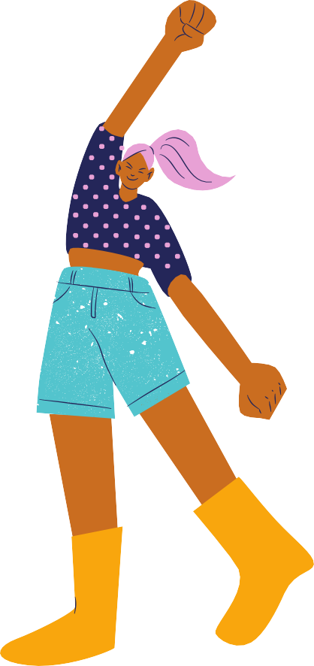
Being a role model through action
Perhaps one of the biggest takeaways from our guide is to underscore that changing attitudes towards race starts at home. Once we as parents understand anti-racism ourselves, we are then able to lead by example to our children.

Being open to change and criticism of current views is a powerful lesson, helping our children become better and conscientious world citizens. Actions often speak louder than words, and our children mirror how we act in day- to-day life. From a young age children take note of our actions, meaning that if you open discussion on race at home, yet treat people differently in view of their race, your children are likely to adopt similar behaviour.

Whilst it's not always easy, as parents we should try to acknowledge and be aware of our own implicit bias. Take note of your gestures, how you look at people, and how you interact with people. Small changes such as these go a long way.

A selection of educational resources for you and
your family (please look
beyond this list as well!):

12.)


Books:

Younger children:
Grace Byers: I am enough (Age 3-8)
A child-friendly simple picture book that reminds us to love ourselves for who we are, to be kind and to respect others

Innosanto Nagara: A is for Activist (1+)
An ABC book packed with definitions and eye-catching pictures that help children engage in and understand activism

Ann Hazzard: Something Happened In Our Town (age 4-8)
The story of a white family and a black family as they explore a police shooting of a Black man in their town. The book aims to help children understand and identify racial injustice and help answer questions on the nature of traumatic events.

Matthew Cherry: Hair Love
A short book and film that narrates an African-American father’s relationship with his daughter and styling her hair. The book encourages love and mainstream exposure to people of colour’s hair.

Cobzi A. Cobrera: My Hair is a Garden
Mackenzie is upset about mean comments about her hair. We follow her story as she learns to love her hair with the help of her neighbour Miss Tillie. Using her garden as a metaphor Mackenzie learns not to fear her hair but to see it as beautiful.

Vashti Harrison: Little Leaders: Bold Women In Black History (Age 7-10)
An illustrated history book of the stories of amazing Black women in history and their achievements

Andrea Davis Pinkey: Let it Shine (ages 5-9)
An illustrated story of Black women doing amazing acts in history, speaking out against racism and oppression.

Fran Manushkin Happy in our Skin (Age 2+)
A book to teach kids about diversity. The illustrations feature children with different skin colours, glasses, freckles, unibrows, wheelchairs, and birthmarks to help encourage the beauty of diversity

Ilyasah Shabazz: Malcolm Little: The Boy Who Grew Up To Be Malcolm X (Age 5-10)
The childhood story of one of the most influential Black American men, Malcolm X, written by his daughter

Ibtihaj Muhammad: The Proudest Blue (Age 4-7)
A beautiful story of being proud of your identity. In the face of hurtful words, Faizah finds the way to be proud of her bright blue hijab.

13.)

Jacqueline Woodson: The Day You Begin (Age 4-7)
The story of finding the courage and bravery to be different and connect with people when you feel alone or when “no one is quite like you"

More here:
https://twitter.com/wanderingbritt_/status/1267617830872154113?s=21

Older children:
Malorie Blackman: Noughts and Crosses series (age 11-16)
Takes social norms and flips them on their head and confronts the legacy of slavery in an engaging and comprehensible manner for teenagers.

Maya Angelou: I know why the caged birds sing (14+)
The first of seven autobiographies of the writer Maya Angelou, describing how her love of literature and personal strength helped her face racism throughout childhood and early adolescence

Angie Thomas: The Hate You Give (14+)
Inspired by the Black Lives Matter Movement this story follows Starr Carter and we follow her journey as she tries to speak up for the tragic death of her childhood friend, Khalil.

Lisa Heathfield: I am not a number (14+)
Set in a dystopian future, we follow the story of the rise of ultra-conservatism through the protagonist Ruby.

Parents (and older children):

The Lonely Londoners: Sam Selvon
The story of black immigrants coming to Britain after WW2, explains how Britain in need treated immigrants with racism and prejudice

Nikesh Shukla: The Good Immigrant
A collection of short personal experiences of the experience of 21 influential British Asian and minority ethnic voices in Britain today. They paint a picture of what it is like to be ‘other’ in Britain today. Poignant, challenging, funny, interesting, and inspiring, this is a must for your teenage child to see Britain outside of a white lens.

Reni Eddo-Lodge: Why I’m no longer talking to White people about race
A sharp wake up call to institutionalised racism and outlines what it means to be a person of colour in Britain in 2020.

Afua Hirsch: Brit(ish)
An exploration into what it really means to be Black and not accepted in British society and how the impact of the past on the present.

14.)

David Olusoga: Black and British: A Forgotten History
A historical exploration of the long relationship between Britain and the people of Africa dating to Roman times.

Bernadine Evaristo: Girl, Woman, Other
A novel that follows 12 women over several decades and a sweeping history of the black British experience

Ijeoma Oluo, So You Want to Talk About Race
An exploration of race in America, aspects of white supremacy--from police brutality to the mass incarceration of African Americans




Websites:

Guide To Allyship https://guidetoallyship.com/ (11+)
Talking about race https://nmaahc.si.edu/learn/talking-about-race (parents) Anti-racism resource list for beginners:
https://docs.google.com/document/d/1S5uckFHCA_XZkxG0Zg5U4GQGbY_RklZARw u43fqJH0E/preview?pru=AAABcqQalEw*P8cjSDUbX97mvZjKJdaMsw (parents and older children)

100 race-conscious things you can say to your child: http://www.raceconscious.org/2016/06/100-race-conscious-things-to-say-to-
your-child-to-advance-racial-justice/ (parents)

Your kids aren’t too young to talk about race: https://www.prettygooddesign.org/blog/Blog%20Post%20Title%20One-5new4? fbclid=IwAR1Xg3lpkvY3t4JVCr8BF9TOa2m- 2gdQxkCD_IPSmmopTquWSxbZQa6cX0Q (parents)

How to talk to kids about race and racism: https://www.parenttoolkit.com/social- and-emotional-development/advice/social-awareness/how-to-talk-to-kids-about- race-and-racism (parents)



podcasts (Click to listen)
Life Kit: Parents. Talking Race with young children About Race. Parents

(Reni Eddo-Lodge) Code: Switch NPR. Parents/Older children

15.)

Not all superheroes wear capes: how you have the power to change the world (TED Talk). Parents/ older children

The Response podcast: Inequality, structural racism, and the fight for justice after the Grenfell Tower fire. Parents/older children

More examples here: https://bellocollective.com/8-podcasts-that-help-you-talk-to- kids-about-race-e5a4b639ac3f

Films:

Younger children / Family
Remember the Titans (PG)
Based on the true story of high school football coach Herman Boone in the 1970s, and how he diffuses racial tensions, teaching his players to come together on and off the field.

Hidden Figures (PG)
Based on the true story of three mathematicians in the 1960s — Katherine Johnson, Dorothy Vaughan, and Mary Jackson. This film portrays how these three women overcame race and gender obstacles and become key members of NASA.

Queen of Katwe (PG)
Set in Katwe, Uganda, 10-year-old Phiona Mutesi’s life changes forever after a visiting missionary teaches her how to play chess. She becomes an international chess star, and we follow how she faces poverty, violence, and racism along the way.

Akeelah and the Bee (PG)
The story centers around Eleven-year-old girl from south Los Angeles, Akeelah. Her mother works incredibly hard and she lost her dad at six. We watch as Akeelah learns to believe in her capabilities and overcome challenges to compete at spelling bees.

The Boy who Harnessed the Wind (PG)
Based on a true story, this film depicts William Kamkwamba, a 13-year-old boy who devises a way to save his Malawi village from famine.

The Painting (U)
An animated metaphor for racism. Originally a French film we explore a kingdom is divided into the three castes: the impeccably painted Alldunns; the Halfies who the Painter has left incomplete; and the untouchable Sketchies

The Princess and the Frog (PG)
Disney’s first on-screen Black Princess, this story follows Tiana on her journey to opening her own restaurant. A kind-hearted, funny, and lovely story of turning a frog prince back into a human being.
16.)

Coach Carter (12A)
Based on a true story, a sports store owner accepts the job of basketball coach for his old high school. He sets out on a mission to change things attitudes surrounding relationships with others, kindness, and education to ensure his team has access to the best opportunities in life after high school.

The pursuit of happiness (12A)
Based on a true story of a father-son family the film follows a father and son rise from the bottom rung of the ladder in 1980s San Francisco

The Hate You Give (12)
Based on the novel and inspired by the Black Lives Matter Movement this story follows Starr Carter and we follow her journey as she tries to speak up for the tragic death of her childhood friend, Khalil.

Biographical films (older children and parents)

Becoming (PG)
Join former first lady Michelle Obama in an intimate documentary look at her life, hopes and connection with others as she tours with

Becoming Mandela (Long walk to freedom) (12)
A chronicle of Nelson Mandela's life journey from his childhood in a rural village through to his inauguration as the first democratically elected president of South Africa, depicting Mandela’s viewpoint on the apartheid years.

Who killed Malcom X? (12)
A Netflix miniseries following the work of Abdur-Rahman Muhammad, a historian who has been investigating the assassination of Malcolm

X.Ray (15)
An award-winning independent film focusing on the life of Ray Charles, a pioneer of soul music with one of the most recognisable voices in American music who went blind at the age of seven

Ali (15)
A biography of Muhammad Ali following his heavyweight boxing career, conversion to Islam and criticism of the Vietnam War during a time of social and political upheaval following the assassinations of Malcolm X and Martin Luther King.

Malcolm X (15)
A dramatised biopic following key events in the life and upbringing of Malcolm X, one of the most well-known civil rights and black empowerment activists.

What Happened, Miss Simone? (15)
A biography of the life of American singer and civil rights activist Nina Simone, combining unreleased archive footage and interviews with her daughter and friends.

17.)

King in the Wilderness (R)
A HBO produced biography on the last 18 months of Martin Luther King Jr'.s life. Very current, especially with the discussions of non-violence and the current discourse surrounding how to protest.

Contextual / political dramas: appropriate for older children and parents
Green Book (12A)
Inspired by a true story, world-class African-American pianist Dr Don Shirley embarks on a concert tour of the Deep South in 1962, recruiting a tough-talking Italian- American bouncer from the Bronx as his driver and protection. The two men develop an unexpected bond while confronting racism and danger in an era of segregation.

The Help (12A)
A period drama set during the Civil Rights Movement in 1963 Mississippi following the story of a young white aspiring journalist “Skeeter” who writes a book from the perspective of two black maids, Aibileen Clark and Minny Jackson, exposing the racism and hardships they are faced with, causing life in their town to never be the same again. (note: film is shown predominantly through white lens/white storytellers)

American History X (15)
An American crime drama film following a former neo-Nazi imprisoned for killing two black youths who vows to change his racist, violent ways, struggling with his own deeply ingrained prejudices and wondering if his family can overcome a lifetime of hate.

Do The Right Thing (15)
A local becomes upset when he sees that his local pizzeria in a predominantly black neighbourhood only shows Italian actors on their Wall of Fame, rather than black actors. The wall becomes a symbol of racism and hate to the neighbourhood and tensions rise on the hottest day of the year.

Moonlight (15)
The first award-winning film with an all-black cast and LGBTQ-related following the youth, adolescent and early adult life of Chiron, exploring the difficulties he faces with his sexuality, identity and abuse he endured growing up.

Historical films about slavery: appropriate for older children and parents

Amistad (15)
A historical drama based on true events aboard the slave ship “La Amistad” following the events in which the kidnapped Mende tribesmen managed to gain control of their captor’s ship, and the international legal battle that ensued.

12 Years a Slave (15)
An adaptation of the 1853 slave memoir by Solomon Northup, this biographical period drama follows his life after he was kidnapped and sold into slavery by two conmen for
12 years before being released. 18.)

Documentaries: appropriate for older children and parents

13th (15)
A powerful documentary that addresses racial issues confronting America in 2016 including police brutality and mass incarceration (currently available on Netflix)

The Black Power Mixtape (12A)
A documentary film, directed by Göran Olsson, that examines the evolution of the Black Power movement in American society from 1967 to 1975 through the lens of Swedish filmmakers

When They See Us (15)
Based on a true story, five teens from Harlem are falsely accused of a brutal attack in Central Park.

Chris Rock’s Good Hair (PG-13)
A documentary film focusing on the issue of how African-American women have perceived their hair and historically styled it, exploring the current styling industry for black women, images of what is considered as acceptable or desirable and their relation to African-American culture.

When the Moors Ruled in Europe (Youtube)
An eye-opening Youtube documentary highlighting the Moors’ architecture and intellectual accomplishments in Spain, information which has been systematically written out of history since the 1500's.

Paris is Burning (15)
An invaluable documentary to the end of the “Golden Age” of New York City drag balls and a thoughtful exploration of race, class, gender and sexuality in America.

Self-Made (Inspired by the life of Madam C.J. Walker) (Netflix series)
Based on a true story, an African American washerwoman rises from poverty to build a beauty empire and become the first female self-made millionaire.

The Tulsa Lynching of 1921 (15)
This is a Documentary of the infamous Tulsa Massacre of 1921, locally called "The Tulsa Race Riot." Most of the Black section of town was burned and many Black citizens were murdered by roving gangs of White racists.

Black Wall Street Burning (R)
A retelling of the worst act of American terrorism and racism in American History. The Tulsa race massacre of 1921 took place on May 31 and June 1, 1921, when mobs of white residents attacked black residents and businesses of the Greenwood District in Tulsa, Oklahoma.

19.)

Written by Lily Pryer and Francesca Chong, with special contributions from Mischa Macaskill, Saffia Anderson and Idris Mhiri.

Special thank you to all those who have spoken up against the discrimination to help us understand, even though they don't owe us an explanation of the pain felt.

Further credits: Twitter threads Semaj Mitchell, Brittany, and Makayla Butler

Kris Staub illustration on Black Lives Matter https://www.krisstraub.com/

Good Housekeeping What Black Lives Matters Mean https://www.goodhousekeeping.com/life/a32745051/what-black-lives-matter- means/

The Guardian https://www.theguardian.com/commentisfree/2020/jun/09/protests-british- history

National Geographic https://www.nationalgeographic.com/family/in-the- news/talking-about-race/

Woman’s Day https://www.womansday.com/life/entertainment/g32745225/movies-about-race- racism-kids/

Gal-Dem Magazine https://gal-dem.com/the-death-of-shukri-abdi-she-was-failed- when-she-was-alive-and-shes-still-being-failed-now/

Bello Collective https://bellocollective.com/8-podcasts-that-help-you-talk-to-kids- about-race-e5a4b639ac3f

History.com https://www.history.com/news/8-black-inventors-african- american#:~:text=Carbon%20Light%20Bulb%20Filament%2C%20Invented,African%2 DAmerican%20inventor%20Lewis%20Latimer

20.)

